# SmartSleep Analyzer as an Angular Element

**Following is an itemized list of things necessary to create an Angular Element, starting with an existing Angular Application.**

## Angular 7+

Upgrade to the latest version of angular, this will ensure that you will receive the best support, documentation and features.

## Eliminate the assets folder

Eliminate all asset files and resources that are contained in the assets folder. Do this by embedding resources such as images, fonts and icons directly in the HTML and CSS files.

## Eliminate all 3rd party libraries

Eliminate all third-party libraries such as bootstrap and jQuery. You should find everything you need by implementing with Angular Material. This will give you animation, reactive styling, modal dialogs and mobile support.

## Base64 Encoding

You can utilize base64 encoding to integrate images, icons, and fonts into the HTML and CSS. Background images can also be encoded directly into CSS.

## Styles.scss (styles.css)

All styles should be included in 1 styles.scss file. This will later become the styles.css, and the only dependency needed by the Angular Element.

## Template HTML

All components should have the template HTML embedded directly into the component, instead of using the templateURL to reference a standalone HTML file.

## Eliminate Routing

Eliminate the concept of routing as well as bookmarking HTML pages. They do not have a place in an Angular Element. Instead, use a ViewChild component that you can add dynamically into the DOM of the application. Using this technique will greatly simplify and reduce the size of the application.

## Scaffolding changes

The scaffolding changes are contained in the AppModule. Below is an example of the types of changes.

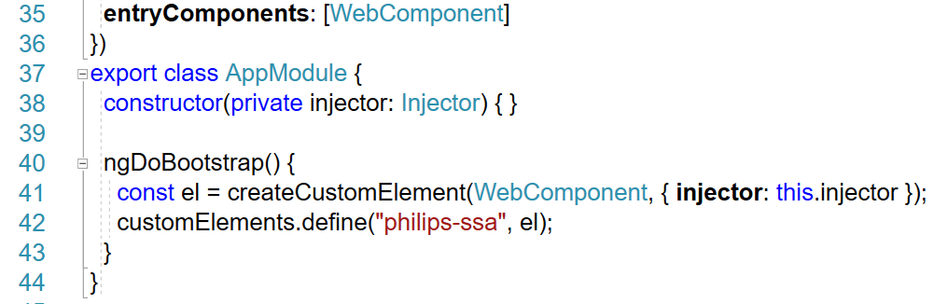

## Production switches

Here are the command line switches necessary to build and Angular Element:

ng build --no-deleteOutputPath --outputPath ./dist/webComponent --prod --output-hashing none --baseHref=/dist/webComponent/ && node bundle-webComponent.js

## Steps to create the SmartSleep Analyzer Angular Element:

These are the steps to use after design and implementation of your Angular Element. Now you are ready to build the Angular Element.

* After implementation and ready to build. Everything works as expected in Dev
* Embed the images into the HTML files
* Embed the HTML files into the Angular components
* Build first level production (dist/webComponent) includes:  
  JavaScript bundles, assets, and styles.css
* Build a single file, (dist/webComponent/ngElement) includes:  
  concatenate to 1 JavaScript bundle, ngElement.js  
  References styles.css from webComponent folder
* Refactor to deliver a single file, (dist/webComponent/ngElement/production) includes 3 files:  
  Index.html, ngElement.js, styles.css

## Remaining efforts

This is a short list of efforts necessary to complete the SmartSleep Analyzer. Some of these effort can be accomplished concurrently.

* Connecting to backend through a WebApi endpoint
* navigate through the analyzer’s questions by integrate with the decision tree logic
* Complete the css styling
* Integrated security: authentication and authorization
* Create an API to communicate with the Angular Element